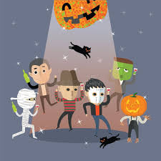
Dear Parents and Guardians,
As Halloween approaches, we know many of our students are excited to celebrate the day at school. Students are welcome to wear costumes, but we do ask that families follow a few important guidelines to keep the day fun and safe for everyone:
Costumes should be school appropriate.
- No weapons or weapon-like props of any kind.
- No political costumes or messaging.
- No full-face coverings or masks that hide a student’s identity.
- Costumes should not disrupt learning or the school day.
In addition, we are excited to announce the 7/8th Grade Halloween Dance after school. Students are welcome to wear their costumes to the dance as well, with the same expectations listed above. This ensures that all students can enjoy the event in a safe and respectful environment.
The 7/8th Grade dance will be a combined dance with North Rockford Middle School. This year NRMS will be hosting the dance and transportation from ERMS to NRMS will be provided and it will be a drop only. Students will need to be picked up at NRMS at 4:15. Cost to attend the dance is $10 (no costume) and $5 (costume) cash only, please. There will be dancing and concessions will be open (cash, card and Apple Pay). Looking forward to a spooktacular good time!
We appreciate your support in helping us make this a safe, enjoyable experience for all students both during the school day and at the dance. If you have any questions about what is or isn’t appropriate, please feel free to reach out to the office before Halloween.
Thank you,
Derek Dillon
Assistant Principal

