

**Rockford Public Schools**

**Wellness Community Resource Guide**

**2025-2026**

**Emergency/Crisis Mental Health Support**

**Network 180**

Access Center

616-336-3909

Open 24 hours-walk-in

790 Fuller Ave NE

Grand Rapids, MI 49503

**Children’s Crisis Mobile Response Team (Network 180)**

616-333-1000

Monday-Friday 9am-9pm

Saturday-Sunday 11am-9pm

Same-day appointments for assessment. Please call as early as possible. They have a mobile unit and will come to you.

**Helen Devos Children’s Hospital**

866-989-7999

Open 24 hours

100 Michigan St NE,

Grand Rapids, MI 49503

**Pine Rest**

616-455-9200

300 68th Street SE  
Building E (Blue), Entrance E1  
Grand Rapids, Michigan 49548

**Forest View Hospital**

616-942-9610

Toll-Free 800-949-8439

1055 Medical Park Dr SE

Grand Rapids, MI 49546

**Children’s Advocacy Center (CAC)**

<https://cac-kent.org/>

616-336-5160

2855 Michigan Ave

Grand Rapids, MI 49506

The Children’s Advocacy Center offers a variety of services and programs geared around topics of sexual assault, sexual/emotional/physical abuse, and safety/prevention. Programs include forensic interviews, family advocacy, therapy, case management, support for parents and victims, and education.

**National Suicide Lifeline**

Call: 988

Open 24 hours

The 988 Lifeline provides confidential support to people in suicidal crisis or mental health related distress. Calling or texting this line will connect you to a mental health professional with the lifeline network.

**Assessment/Testing Resources**

**North Kent Guidance**

<http://northkentguidance.com/>

616-361-5001

5250 Northland Dr. NE, Suite A

Grand Rapids, MI 49525

North Kent Guidance offers various types of testing and outpatient therapy options for private insurances and some forms of Medicaid. Offices are located close to our Rockford community!

**Behavior Health Partners (BHP)**

<http://behaviorhealthpartners.com/>

616-363-5337

5242 Plainfield Ave. Suite A

Grand Rapids, MI 49525

Behavior Health Partners offer various types of testing, Autism Spectrum Disorder testing, ABA therapy, and outpatient therapy options for private insurances and some forms of Medicaid.

**Integral Psychological Services**

<https://www.integralpsy.com/>

616-600-2845

8 E. Bridge St NE #C2

Rockford, MI 49341

Services include ADHD Testing, Academic Testing, Cognitive Testing, Personality Testing, DSM diagnoses, Bariatric pre-survey evaluation, and outpatient therapy. Insurances accepted include Blue Cross Blue Shield, Priority Health, United Health Care, Medicare

**Brains**

<http://brainspotential.com/>

616-365-8290

3292 N. Evergreen Dr. NE

Grand Rapids, MI 49525

Brains offers individual and group therapy options for most private insurances and some Medicaid insurances. They also offer some ABA therapy services and an assortment of social skills groups. They provide occupational therapy, trauma focused therapy, cognitive behavior therapy, dialectical behavior therapy, and family focused therapy.

**Pine Rest Psychological Consultation Center**

<https://www.pinerest.org/locations/psychological-consultation-center/>

616-281-6382

6500 Byron Center Ave SW # 300

Byron Center, MI 49315

Pine Rest’s Psychological Consultation Center specializes in assessing the relationship between behavior and brain functioning. Clinicians use state-of-the-art tests and a comprehensive clinical history that generally includes an interview, discussion with family members and a review of school and medical records. The goal is to provide an in-depth understanding of a person’s strengths and weaknesses that can yield helpful recommendations for short and long-term treatment planning.

**Counseling Resources**

**Allow Therapy Partners**

<https://www.allowtherapy.com/>

877-255-6987

Multiple Locations:

1324 Lake Dr Suite #8 6739 Courtland Dr NE Suite #203

Grand Rapids, MI 49506 Rockford, MI 49341

Allow Therapy Partners offers a wide range of trauma-informed and trauma-responsive tools. Offers a strengths-based approach, to employ cutting-edge therapeutic interventions including: Eye Movement Desensitization and Reprocessing (EMDR), Cognitive Behavioral Therapies, Mindfulness, Body Awareness, Movement Therapy, Emotional Regulation, Self Compassion and the Live Brave Method.

**Counseling Center of West Michigan**

<https://www.counselingcenterwm.org/>

616-805-3660 ext. 1123

Multiple locations including Rockford, Grand Rapids, Cascade, Greenville, and more

502 Northland Dr NE Suite 100

Rockford, MI 49341

**Grand Rapids Pride Center**

[**https://grpride.org/portfolio-item/youth-group/**](https://grpride.org/portfolio-item/youth-group/)

616-458-3511

343 Atlas Ave SE

Grand Rapids, MI 49506

The Pride Center is aimed at empowering our LGBTQ+ community through supportive services and awareness. The Pride Center offers multiple social and support groups.

**Wedgwood Christian Services**

[**http://www.wedgwood.org/**](http://www.wedgwood.org/)

616-942-7294

3300 36th St. SE,

Grand Rapids, MI 49512

Wedgwood offers a full continuum of child and family services, including the area’s primary option for group and individual adolescent substance abuse support. Services also include Psychological Testing, Abuse/Neglect Support, Trauma Support, Dialectical Behavior Therapy (DBT), and several residential programs for adolescents. Wedgwood also offers alternative school learning environments that include Lighthouse Academy and Hope Academy.

**Epic Discoveries Counseling**

<http://www.epicdiscoveries.com>

4867 E Beltline Ave NE Building 1 Suite 400

Grand Rapids, MI 49525

616-202-2253

Epic Discoveries believes that growing in self-awareness and emotional freedom are epic achievements! The way we see it: you are on one *incredible* journey and you cantriumph as the hero of your one-of-a-kind story. We know the path can be steep and rocky, yet the progress is worth every step.

**Spot to Talk**

[www.spottotalk.com](http://www.spottotalk.com)

8 E Bridge St Suite E1

Rockford MI 49341

406-890-6786

Spot to Talk is a therapy experience that strives to support all clients by cultivating an authentic and communicative therapeutic relationship to meet one’s individual needs. Therapists are dedicated to connecting with clients in an individualized and non-judgmental manner. Spot to Talk specializes in Child Centered Play Therapy for ages 2-13 to help children develop self-control, self-responsibility. Therapists also support adolescents and adults dealing with anxiety, depression, grief and loss, identify formation, OCD, substance use challenges, school refusal, relationship challenges, and family dynamics.

**Rockford School Assistance Program**

Pine Rest’s School Assistance Program (SAP) is a free, confidential resource available to students, families, and school staff. It offers short-term counseling as well as free consultations on a wide range of issues, including stress, anxiety, depression, grief, behavioral concerns, family or relationship challenges, substance use, and school-related difficulties. SAP also provides free legal, elder care, financial, real estate, and infant feeding consultations. See flier below for scheduling options including over the phone or online.



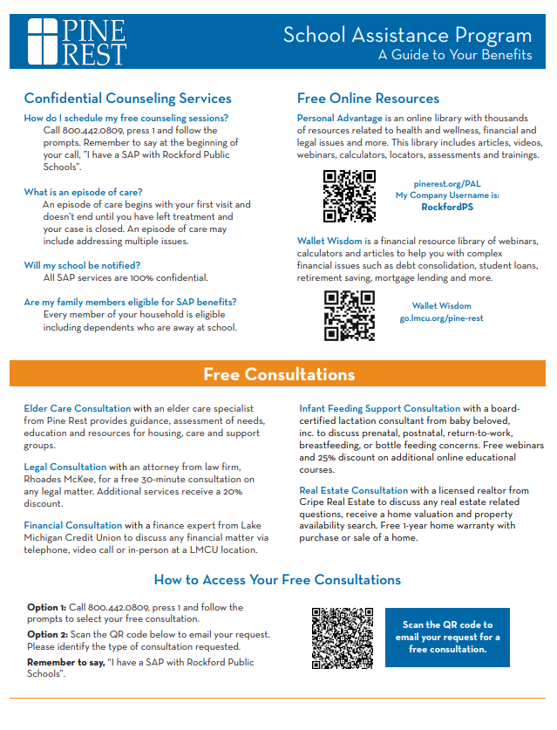

**Basic Needs**

**211**

<https://www.211.org/>

Dial 2-1-1

Sponsored by the United Way

Calling 211 in Michigan connects individuals with free, confidential help for essential needs. Trained specialists provide information and referrals for housing, food, utilities, health care, mental health, and other community resources. Available 24/7, 211 ensures people quickly access local support services in times of need.

**Find Help**

<https://findhelp.org/>

Findhelp.org is an online search platform that connects people to free or reduced-cost local resources. By entering a zip code, users can find programs for food, housing, utility assistance, healthcare, transportation, job training, and more. It helps individuals and families easily access community services tailored to their needs.

**North Kent Connect**

<https://nkconnect.org/>

616-866-3478

North Kent Connect is a nonprofit organization in northern Kent County, Michigan, that supports individuals and families facing economic hardship. It provides food, clothing, financial assistance, and case management, while also offering classes, job training, and resources that promote stability, independence, and long-term self-sufficiency within the community.

**Additional Helpful Resources:**

**Information about Anxiety:**

* [Anxiety: A Brief Overview](https://drive.google.com/file/d/1yLkvIb55IepXPbm99rZl99RFwKwJwPrI/view?usp=sharing)
* [What is Anxiety?](https://drive.google.com/file/d/1MdpzpYeKeW1KmT4vcmaSGveoGIMgBx8U/view?usp=sharing)
* [10 Signs of Anxiet](https://drive.google.com/file/d/1kgT54aZUUKa4l6PMU3AbCvBS7uhlbdpK/view?usp=sharing)y

**Information about Depression:**

* [What is Depression?](https://drive.google.com/file/d/1EjYdORr5l8ElhVqWfe1USQi11cEsPJJf/view?usp=sharing)
* [What Depression Actually Feels Like](https://drive.google.com/file/d/1nu3lUIMq71FN2R8CbATngrk1s9JHxBOw/view?usp=sharing)
* [Signs of Depression in Children](https://drive.google.com/file/d/1xoTef-1aet7dcqQvwiHy4GbWTvvhgcNe/view?usp=sharing)

**Rockford Public Schools Mental Health Liaisons**

Colton Cnossen David Jangda

Elementary Secondary

[ccnossen@rockfordschools.org](mailto:ccnossen@rockfordschools.org) [djangda@rockfordschools.org](mailto:djangda@rockfordschools.org)